**Module 3 Critical Thinking: Option 1**

Andrew Barnes

Colorado State University Global

CSC320-1

Dr. Schwartz

9/3/2023

**Pseudo Code**

1. Initialize input scanner

2. Prompt the user: "Enter your weekly income: $"

3. Read income as a double

4. Initialize variable taxRate as double

5. IF income < 500 THEN

5.1. SET taxRate to 0.10 (10%)

6. ELSE IF income < 1500 THEN

6.1. SET taxRate to 0.15 (15%)

7. ELSE IF income < 2500 THEN

7.1. SET taxRate to 0.20 (20%)

8. ELSE

8.1. SET taxRate to 0.30 (30%)

9. Calculate taxWithheld as income multiplied by taxRate

10. Output: "Your weekly average tax withholding is: $" + taxWithheld

**Source Code**

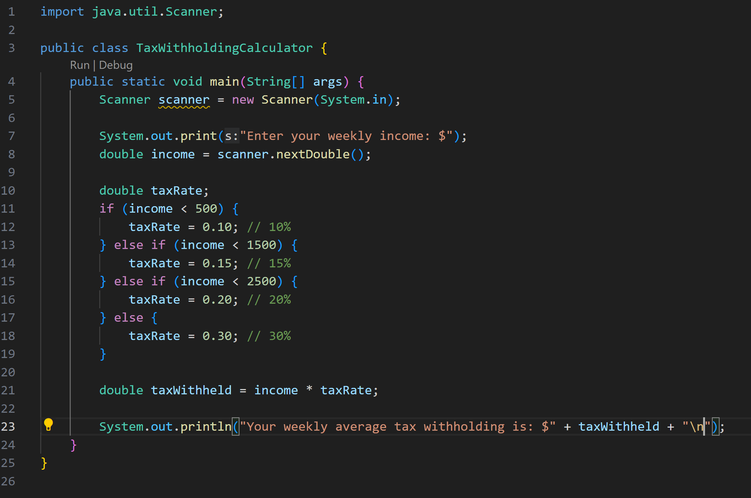

**Executing the Application**

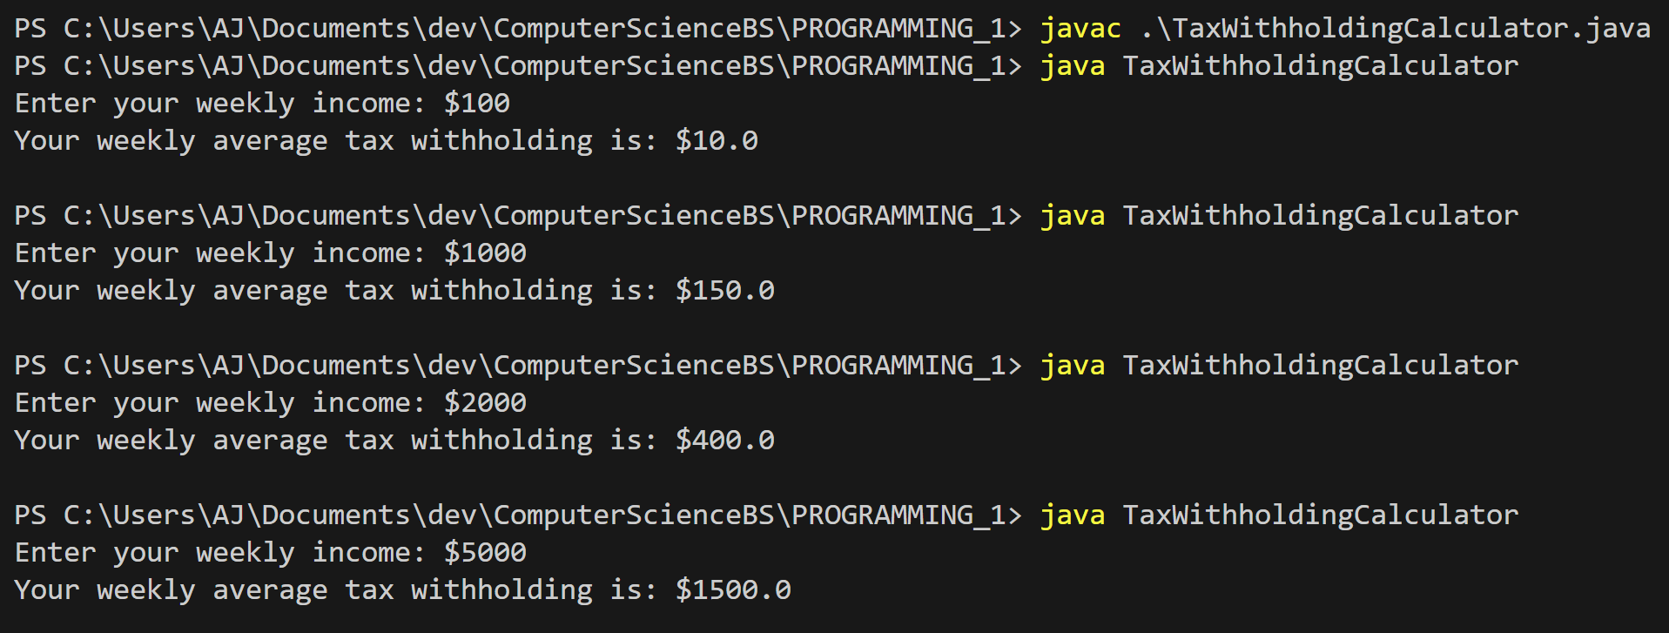

**Git Repository**

**Git Status**

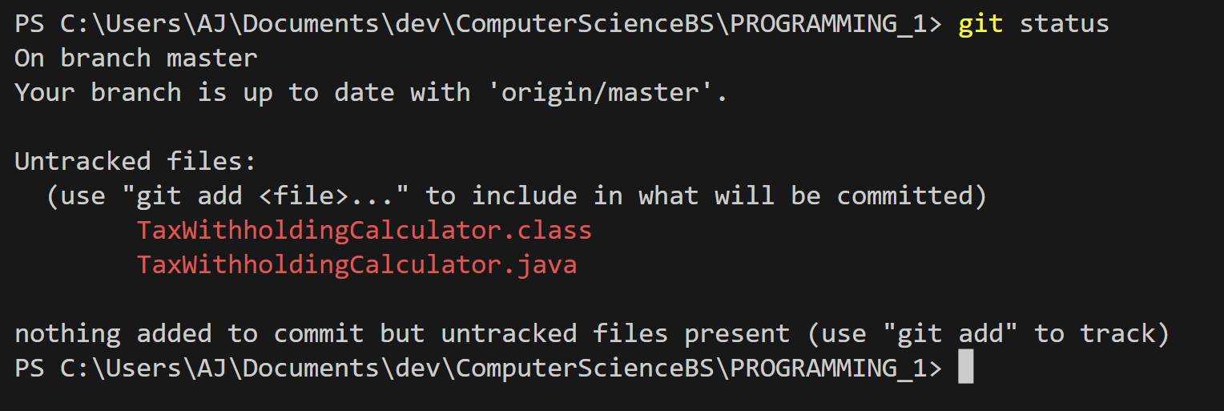

**Git Add**

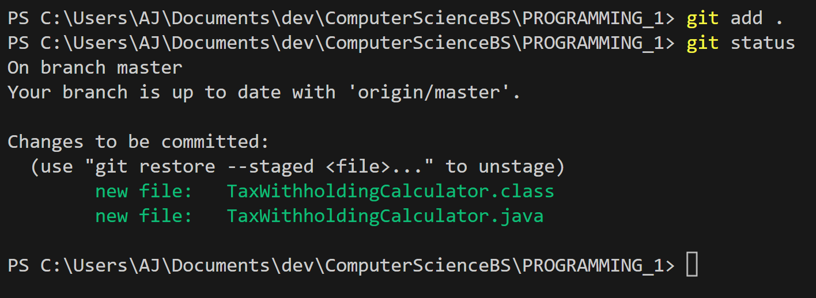

**Git Commit**

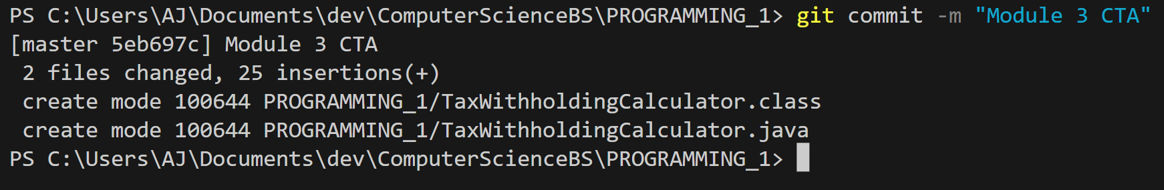

**Git Push**

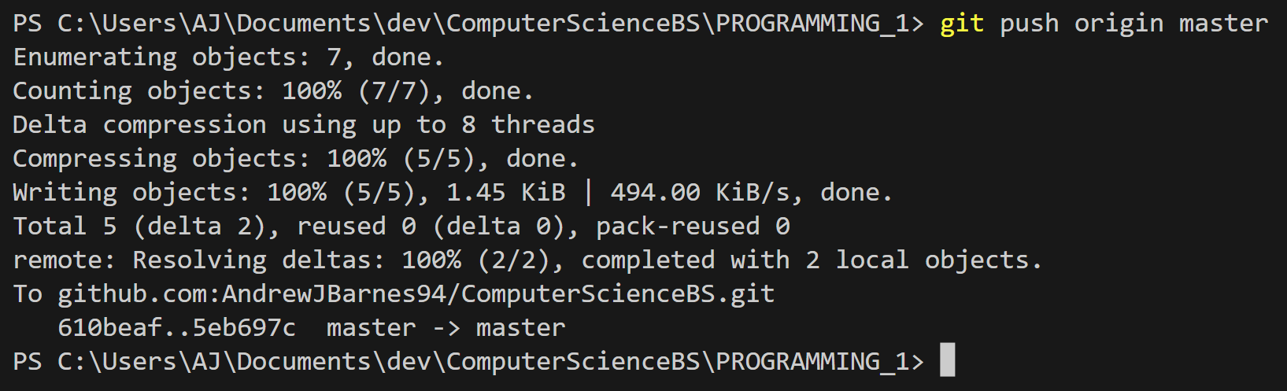

**GitHub Repository**

[**ComputerScienceBS/PROGRAMMING_1/TaxWithholdingCalculator.java at master · AndrewJBarnes94/ComputerScienceBS (github.com)**](https://github.com/AndrewJBarnes94/ComputerScienceBS/blob/master/PROGRAMMING_1/TaxWithholdingCalculator.java)